**Project Design Phase-II**

**Technology Stack (Architecture & Stack)**

|  |  |
| --- | --- |
| Date | 28 June 2025 |
| Team ID | LTVIP2025TMID55291 |
| Project Name | **FreelanceFinder: Discovering Opportunities, Unlocking Potential** |
| Maximum Marks | 4 Marks |

**Technical Architecture:**

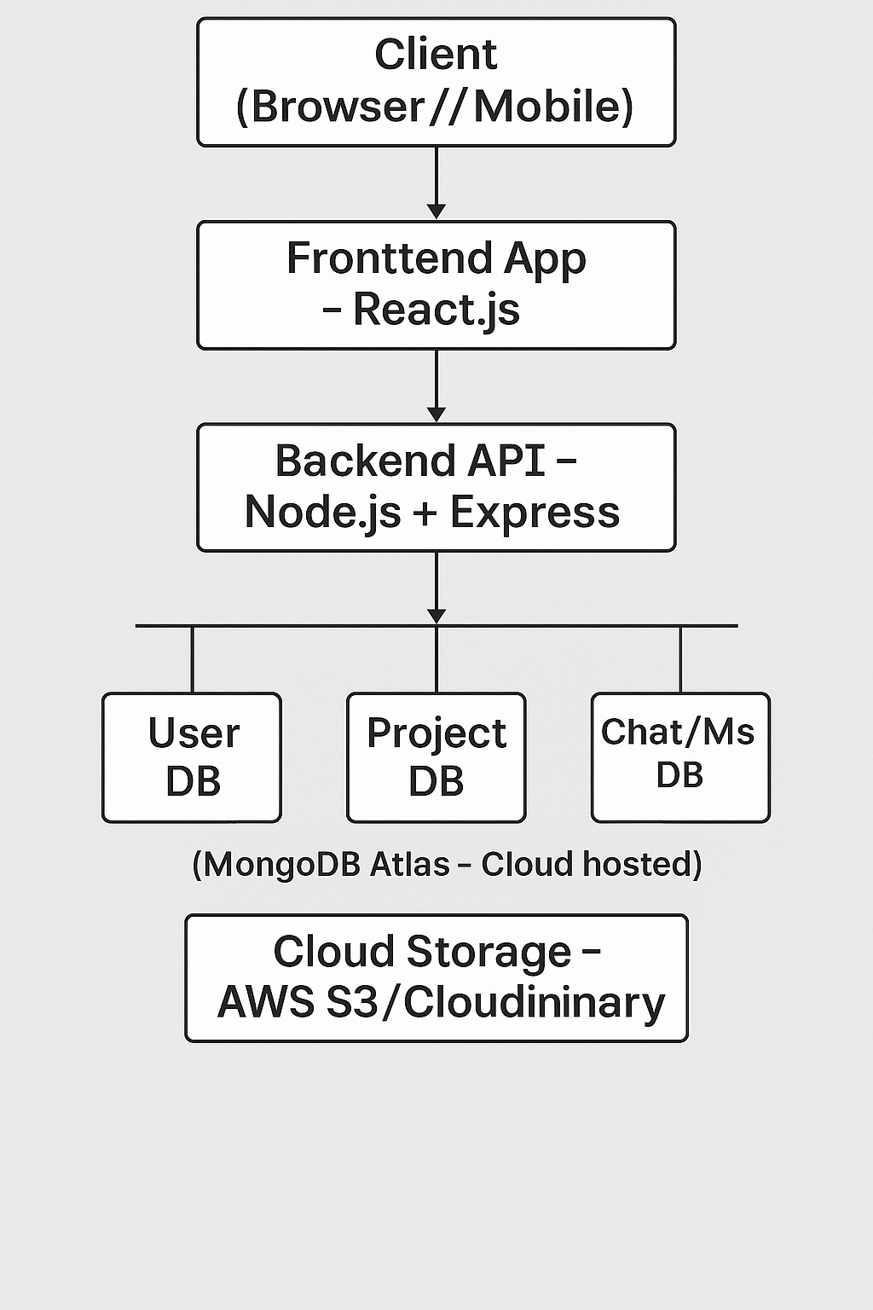

|  |  |  |  |
| --- | --- | --- | --- |
| **S.No** | **Component** | **Description** | **Technology** |
|  | User Interface | Web UI for clients and freelancers | HTML, CSS, React.js, Bootstrap, Material UI |
|  | Application Logic-1 | Business logic for user actions, project posting, proposals | Node.js, Express.js |
|  | Application Logic-2 | Chat handling, rating system, proposal matching | Socket.io, Node.js |
|  | Database | User, Project, Application, Chat collections | MongoDB |
|  | Cloud Database | Cloud storage for scalability and redundancy | MongoDB Atlas |
|  | File Storage | Uploading resumes, portfolios, project files | Cloudinary / AWS S3 / Local storage |
|  | External API-1 | Authentication (Gmail, LinkedIn) | I Google OAuth API, LinkedIn AP |
|  | External API-2 | Optional: Government ID verification (e.g., Aadhaar) | Aadhaar Authentication API (if used) |
|  | Infrastructure (Server / Cloud) | App deployment and management | Local Dev: Node.js, Cloud: Vercel (Frontend), Render (Backend) / AWS / Railway.app |

**Table-2: Application Characteristics:**

| **S.No** | **Characteristics** | **Description** | **Technology** |
| --- | --- | --- | --- |
|  | Open-Source Frameworks | Backend & frontend development frameworks | React.js, Node.js, Express.js, Mongoose |
|  | Security Implementations | Data protection, secure auth, access control | JWT, Bcrypt, HTTPS, CORS, OWASP guidelines |
|  | Scalable Architecture | Decoupled front-end and back-end, supports scaling | 3-tier Architecture, Microservices-ready |
|  | Availability | Cloud hosting, uptime, fallback | MongoDB Atlas, Load Balancers, Auto-scaling Groups |